Light and Shadows

 | It is by the light of stars that we see the Universe and in particular it is the Sun that lights up the solar system, the Moon, planets, moons, asteroids and comets give off no light of their own.  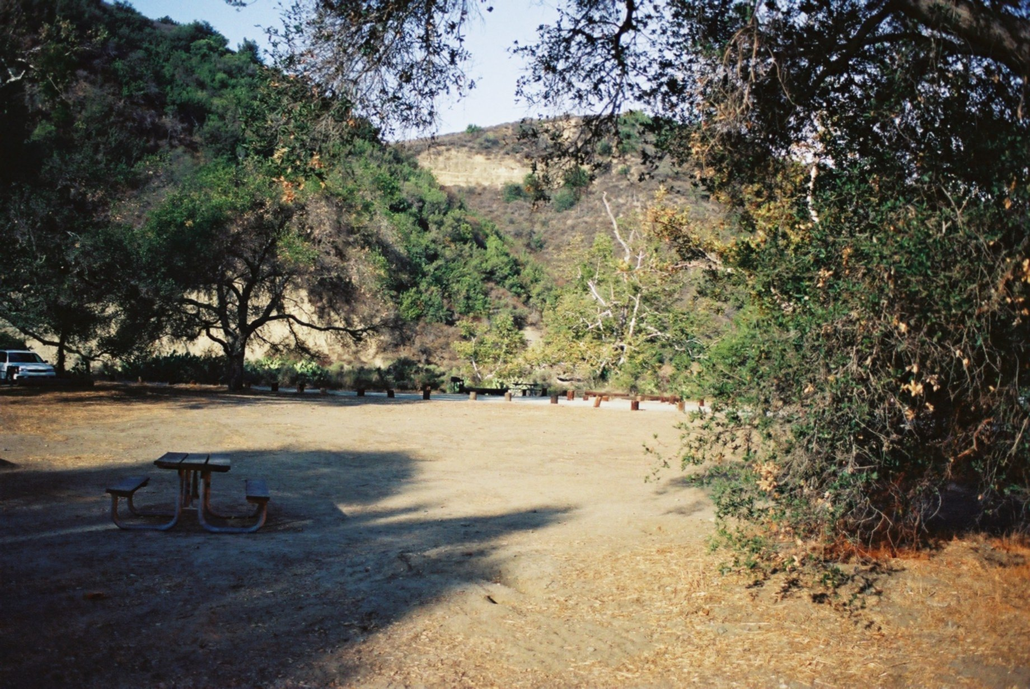  This photograph was taken in the middle of the night, by the light reflected off the Moon. From Earth we can therefore see the Moon as it slowly orbits us. We might see the phases of the Moon change over a period of one month (one moonth!).  The Sun gives us light to light our daytime and as we spin around on the Earth we face away in the night time.  If we look carefully we can see the shadows of trees, buildings and things move as the Sun changes position in the sky. When we sunbathe we need to move ourselves around to face the Sun as it moves through the day. It is also the reason why the Sun comes up on one side of your house and sets on another!  It is sometimes hard for us to realise that it is the Earth that is spinning when we see this effect. So go out in the sunshine stick up your thumb in front of you and hold it a little away from your tummy and turn slowly around and around to your left. If you look down you will see the shadow of your thumb move across you clothes!

